**Modeling and simulation of a communication system for Distribution Power System -Case Study University Campus**

Jesus Ortiz Sandoval

Universidad Tecnica Federico Santa Maria

Valparaiso, Chile

1. **Introduction**

Smart grid is a project that involves many disciplines and that brings many economic, political and legislative challenges of the countries that have decided to implement this technology. One of the main implementations of this technology is related to the stabilization of the load in the Grid that can be impacted by the inclusion of electric vehicles with the energy peaks that occur at the time of loading.

In addition to being able to control the behavior of energy, there are also many challenges, some mainly in the infrastructure, because when the electricity distribution networks were established, we never imagined that the technological revolution would reach the point we have today, and the implementation of smart cities will be sought.

For this reason, the different architectures that can be implemented in the power distribution systems (DAS) are being studied, evaluating topologies, costs and, above all, allowing a quick and effective transition.

Taking advantage of an economic system such as the EPON, we will model a system that can be implemented in a case study of a university, in addition, simulations will be carried out to verify the theory and comply with the operating requirements found in the IEEE standard. 1588, in addition, simulations of different internal communication architectures are made using wired and non-wired media, analyzing the latency in two possible states at rest and charging.

The following report is divided first into a search of the works related to the area, then an approach to the problem to be discussed, the modeling of the DAS, the simulation and the functional tests of the proposed network architectures in the two states proposed. , to finish with the conclusions of the project.

1. **Work Related**

In the first work we analyze how the generation of input data is automated in programs to simulate electrical distribution systems,this type of programs allows us to analyze voltage, harmonics, abnormal behaviors, and that can be of great help in order to raise and evaluate different distribution architectures in intelligent nodes.(Tadokoro et al., 2018)

Besides that for the approach of these topics you have to do simulations we also find a job in which you evaluate the high performance of the communications architecture in an electricity distribution system oriented to developing countries, this is very interesting and Chile currently by the G20 is considered a country on the road to development, and this article assesses some items such as quality of service (QoS) and the impact of migrogrid on the type of communications architecture that should be chosen.V(Devidas, Ramesh, & Rangan, 2018)

We take as the main point of departure the following article where an EPCON architecture is implemented for the communication of an electrical distribution system, taking this article as a reference it is interesting to analyze the form of evaluation of the impact and performance and whose results can be compared with those obtained in the next proposal.(Ahmed & Kim, 2019)

One of the main factors leading to this type of studies is the introduction of electric vehicles, and the need that these lead to the communes to charge their batteries, in the following work some methods of optimization are proposed. Inclusion of EVs in the grid (V2G).(Hussain, Brandauer, & Lee, 2018)

In addition, it is necessary to analyze the configuration of the electrical systems, the novelties that can be implemented to focus on the communication systems and be able to make an evaluation of the results obtained, these systems should be chosen taking as reference the efficiency and stability of the system .(Kim, Cho, & Shin, 2013)

In structure, communication system of distribution grid could be divided in backbone layer and access layer. Backbone layer realizes the communication among substations, by using SDH/MSTP. Access layer realizes the gather of data from FTU to substations by using industrial Ethernet technology and ethernet passive optical network (EPON) (Guo Jing-tian et al., 2014)

The distribution automation system provides capabilities for a central server to collect operation data such as voltage and current, to monitor and control, generally the operation and manage mode of the DAS usually adopts hierarchichal structure. EPON is a promisin solution for access network because it provides low protocol overhead, higher bandwidth, lower costs, broader service capabilities and easy integration.(Sun, Guo, Ma, & Sun, 2010)

Finally, we will analyze specific case studies, in this case of the Dholera city in India, where they propose the types of distribution systems and their interconnection to communication systems in order to meet the technological requirements of an intelligent city, and where some of the theories related to the communication connection topology that you want to use in this work are confirmed.(Pandya, Velani, & Karvat, 2018)

1. **Problem**

In the theory of communication networks there are several topologies that can be implemented in this type of systems, and each can deliver a better result from a subjective evaluation to an indicator, lost, lost packets, bandwidth, transmission capacity, latency , etc.  
In the current literature, a bus-type architecture is evaluated, evaluating the performance with the losses generated in the transmission through fiber optic conductors, with the infrastructure that is proposed, although a fast connection between the elements is allowed, the delay generated by the splitters, as well as forcing the last units to transfer the packages for all the front units, while maintaining the fiber optic technology, we proposed a new star-type architecture with auxiliary concentrators that would significantly reduce the connection latency but with the drawback that if a connection is lost it would be impossible to recover it, unlike a bus connection that allows to detect this type of errors easily.

One of the main objectives to build the new smart cities of the future is to implement new technologies in all layers of implementation, in our case we will implement a topology that allows us to operate and monitor the distribution system for charging electric vehicles.

We propose an architecture with a star connection that allows to reach a higher speed to be able to make an adequate management of what are the peaks of load produced by electric vehicles.(Huang & Zhang, 2011)

**EPON Design and simulation**

Using a system based on the industrial Ethernet protocol together with a PON network (Passive Optical Network), in this architecture we have an OTL that is an optical transmitter, fiber optic cabling, fiber optic splitters and ONU optical reception units such as appears in figure 1. To design our network, we will first make the network modeling taking as reference table 1 with the values associated with the attenuation of the components and the signal loss inserted in the splitters.

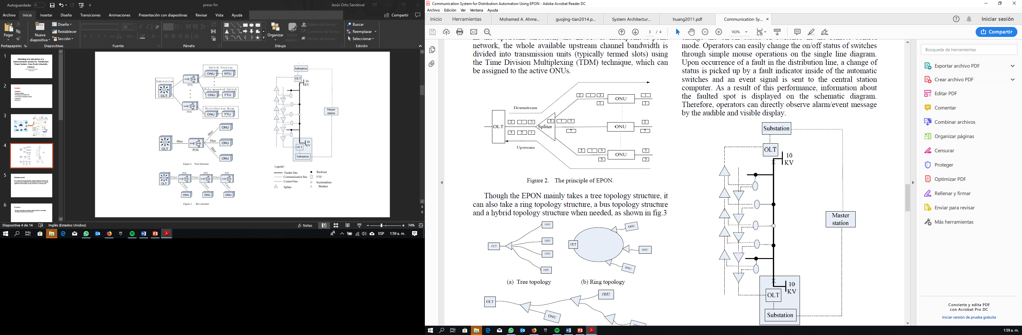

**Figure 1. Arquitectura EPON.**

To be able to do the correct modeling we first analyze the types of architecture that can be implemented, what is desired in this case is to solve one of the main problems that occur in the transition from the grid to a smart grid, which are the costs of implementation and infrastructure, for such a case we must take advantage of the same architecture of electrical distribution, taking for such case bus type infrastructure as we can analyze in figure 2.

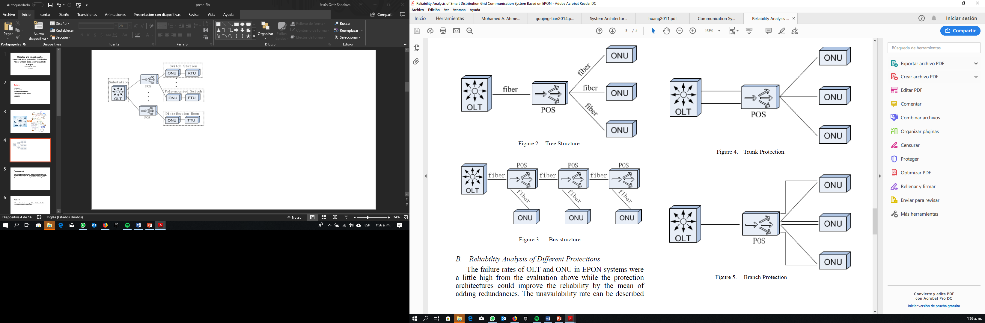

Figure 2. Bus architecture EPON

For this case study, we will take as reference the distribution system of the University of Korea, with reference only to the feeder 1 of the line that has 11 loading units, the main idea of this design is that if the correct operation of the model and simulation can proceed to an adequate implementation. In figure 3 we can see the general diagram of the proposed EPON architecture, and the section that is going to be studied.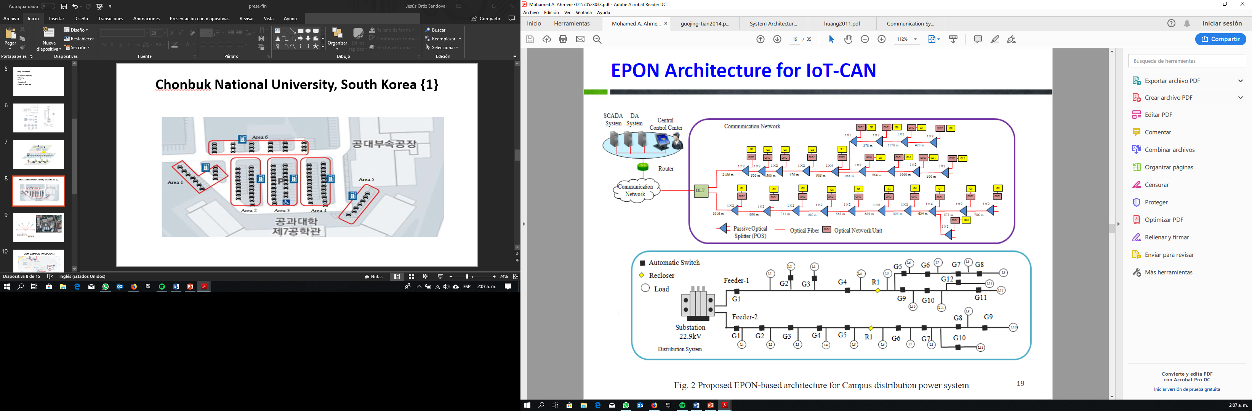

**Figure 3. EPON for case of study.**

A change of the original article is related to the insertion losses that may occur in the splitter, since when the distribution configuration is made 95% and 5% the loss is related in a different way, in a channel we have an attenuation of 0.4dBm and in the other we have a loss introduced in the signal of 11dBm, for this reason we should not do the same modeling for the whole system, we have to do the modeling for the original communication line that goes from the beginning of the substation to the final, and then do the modeling from the OTL to each individual UN station, the main idea is to demonstrate by applying the standard in the 26 dBm transmitter and that the signal will have a magnitude higher than 4 dBm in each station.  
All the data reported in Table 1 of the losses, are completely theoretical, with this information then the modeling is done following the transmission line and the losses that can be induced in the transmission by the optical fiber related to the transmission distance, the connectors at each end, and the splitters that distribute the signal throughout the network.

|  |  |  |
| --- | --- | --- |
| **Component** | **Attenuation** | **Insertion Loss** |
| Fiber | 0.4 dB/Km | N/A |
| Connector | 0.2 dB | N/A |
| Splitter 1x2 | N/A | (5%-95%) (0.4dB -11dB) |
| Splitter 1x4 | N/A | (25%-25%-25%-25%)(6dB-6dB-6dB-6dB-) |

**Tabla 1. Losses associated with each element of the network.**

With this data plus the information found in figure 3, we proceed to make the network design, in table 2 we find the results of the theoretical model of the complete path by the splitter distribution of 95% of the signal, from the substation until the end of the transmission line.

|  |  |  |  |  |
| --- | --- | --- | --- | --- |
| **ONU** | **Fiber Loss** | **Splitter Loss** | **Connector Loss** | **Total Loss** |
| G1 | 0.4064 | 0,4 | 0.6 | 1,4064 |
| G2 | 0.8024 | 0,8 | 1.0 | 2,6024 |
| G3 | 1.0868 | 1,2 | 1.4 | 3,6868 |
| G4 | 1.1648 | 1,6 | 1.8 | 4,5648 |
| G5 | 1.3908 | 2 | 2.2 | 5,5908 |
| R1 | 1.6316 | 2,4 | 2.6 | 6,6316 |
| G6 | 1.7616 | 2,8 | 3 | 7,5616 |
| G7 | 2.0152 | 8,8 | 3.4 | 14,2152 |
| G8 | 2.3652 | 9,2 | 3.8 | 15,3652 |
| G9 | 2.6796 | 9,6 | 4.2 | 16,4796 |
| G10 | 2.0152 | 8,8 | 4.6 | 14,2152 |

**Tabla 2. Loss in main path**

In this case, it can theoretically be determined that the configuration complies with the standards, since the maximum loss found in the ONU G9 is 16 dBm, which guarantees a higher signal than the norm, this information can be used for if it is necessary to add more work units at the end of the distribution line. In Table 3, we do the same modeling but taking as reference only the distribution channel with 5% signal, and keeping the remaining elements such as connectors and the optical fiber of signal distribution.

|  |  |  |  |  |
| --- | --- | --- | --- | --- |
| **ONU** | **Fiber Loss** | **Splitter Loss** | **Connector Loss** | **Total Loss** |
| G1 | 0.4064 | 11 | 0.6 | 12,0064 |
| G2 | 0.8024 | 11.4 | 1.0 | 13,2024 |
| G3 | 1.0868 | 11.8 | 1.4 | 14,2868 |
| G4 | 1.1648 | 12.2 | 1.8 | 15,1648 |
| G5 | 1.3908 | 12.6 | 2.2 | 16,1908 |
| R1 | 1.6316 | 13 | 2.6 | 17,2316 |
| G6 | 1.7616 | 8 | 3 | 18,1616 |
| G7 | 2.0152 | 19 | 3.4 | 13,8152 |
| G8 | 2.3652 | 19.4 | 3.8 | 25,5652 |
| G9 | 2.6796 | 19.8 | 4.2 | 26,6796 |
| G10 | 2.0152 | 19 | 3.4 | 13,8152 |

**Tabla 3. Loss in ONU**

In this special case if we find a special situation, since after the connection of the 1x4 connection splitter, in the G7 station the attenuation is of a value close to 24 dBm, which would be the maximum allowed according to the standard, in the last two stations can present problems with the loss of the signal in this case is that the simulation is a vital tool for our project, as it can give us a clear guidance on the behavior of the network and each of the elements.

To make the simulation we use the OptiSystem software, which as we show in figure 4, allows us to do a complete simulation of all the elements of the network.

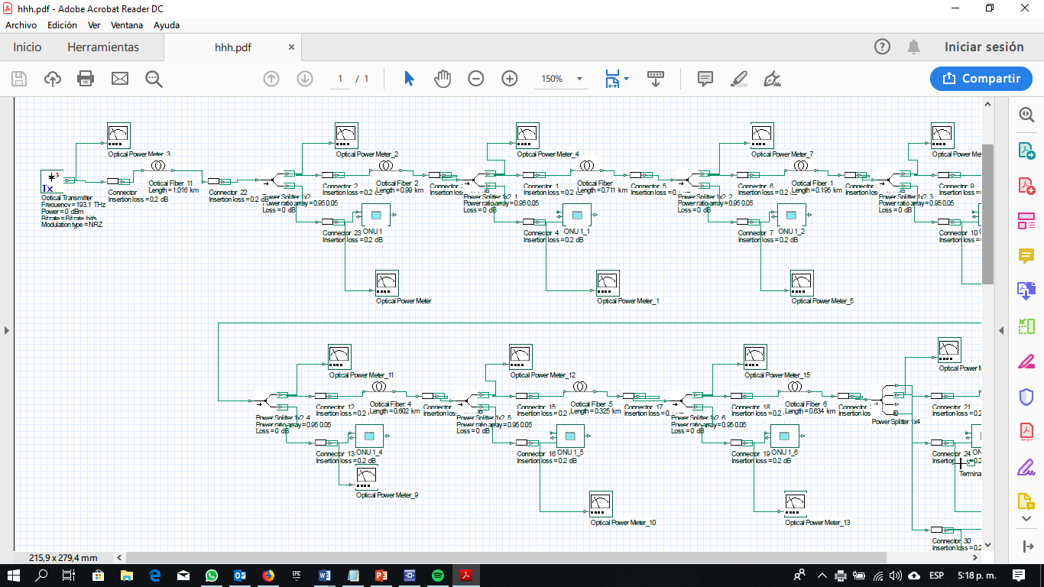**Figura 4. Simulation EPON**

Once we can do the complete and correct simulation of an EPON network of a single terminal we proceed with the real data we have of the situation under study that we have in figure 3 to do the complete simulation with all the variables. Two different measurements are made, the first at the output of the splitter with the channel of 95% of the information that is our original measurement, and the second measurement at the entrance of each of the individual ONUs. In table 4 the results of the simulations are documented, in addition to two columns with the error calculated in each station.

**Tabla 3. Results of simulation**

|  |  |  |  |  |
| --- | --- | --- | --- | --- |
| **ONU** | **Measurement (Path to every ONU)** | **Error dBm** | **Measurement (All Path conection)** | **Error dBm** |
| G1 | 14,016 | **-2,0096** | 1,029 | **0,3774** |
| G2 | 15,035 | **-1,8326** | 2,048 | **0,5544** |
| G3 | 15,943 | **-1,6562** | 2,955 | **0,7318** |
| G4 | 16,643 | **-1,4782** | 3,656 | **0,9088** |
| G5 | 17,492 | **-1,3012** | 4,505 | **1,0858** |
| R1 | 18,356 | **-1,1244** | 5,368 | **1,2636** |
| G6 | 19,108 | **-0,9464** | 6,121 | **1,4406** |
| G7 | 12,995 | **0,8202** | 12,543 | **1,6722** |
| G8 | 26,755 | **-1,1898** | 13,768 | **1,5972** |
| G9 | 27,693 | **-1,0134** | 14,705 | **1,7746** |
| G10 | 12,995 | **0,8202** | 12,543 | **1,6722** |

In the first measure, which is the one oriented towards each ONU, we can verify that in stations G8 and G9 the signal is so attenuated that it does not comply with the requirements of the standard, because the signal that would arrive would be negative, this phenomenon occurs through the inclusion of the 1x4 splitter, the stations after this element are those that suffer the greatest attenuation. Now if we compare the losses we can see that the biggest difference is 2 dBm, this value although it is relevant and is half of what the minimum must have each station is directly related to the splitter, since when making the measurements values ​​are observed different from those indicated in table 1.

In the second measurement point related to the main path we find very close values, starting from an error from 0.3 dBm to the highest value found in the last station of 1.77 dBm, this confirms what was expressed in the last paragraph, since when having a connection in cascade, the error accumulates in each station.

The most important thing about this process is that we can verify in a simulation the values ​​that we find theoretically by modeling the EPON network, this tools is important for when an implementation is carried out, not only the theoretical values ​​are taken into account that sometimes They can be a bit of the values ​​we find in reality.

This section is the most important of the work, as well as what was wanted in the initial evaluation of the project, not only do we want to analyze the losses in the EPON network, we also want to analyze the communication layer in the technology infrastructure, taking as reference the same connection topology and the same materials, in addition to trying a different topology in another case study.

1. **Evaluation of The Network**

Taking as a reference the work done by (Ahmed & Kim, 2019), we will evaluate their behavior but with a different metric than the one evaluated in the paper in question. Since we focus on considering the stability of the network as a critical process and we want to analyze the latency of the devices that belong to the Smart grid and what happens with the latency at the moment that only a few vehicles are transmitting, or what happens when several or even all the vehicles are transmitting.

|  |  |  |  |
| --- | --- | --- | --- |
|  | **1-3 stations** | **4-10 stations** | **>10 stations** |
| Charger 3-1-20 | 42 ms | 42 ms | 42 ms |
| Charger 3-1-18 | 40 ms | 40 ms | 40 ms |
| Charger 3-1-17 | 47 ms | 47 ms | 47 ms |
| Charger 3-1-16 | 36 ms | 36 ms | 36 ms |
| Charger 6-1-5 | 38 ms | 38 ms | 38 ms |
| Charger 5-1 | 22 ms | 22 ms | 22 ms |
| Charger 6-1-15 | 36ms | 36ms | 36ms |
| Charger 4-1-7 | 34 ms | 34 ms | 34 ms |

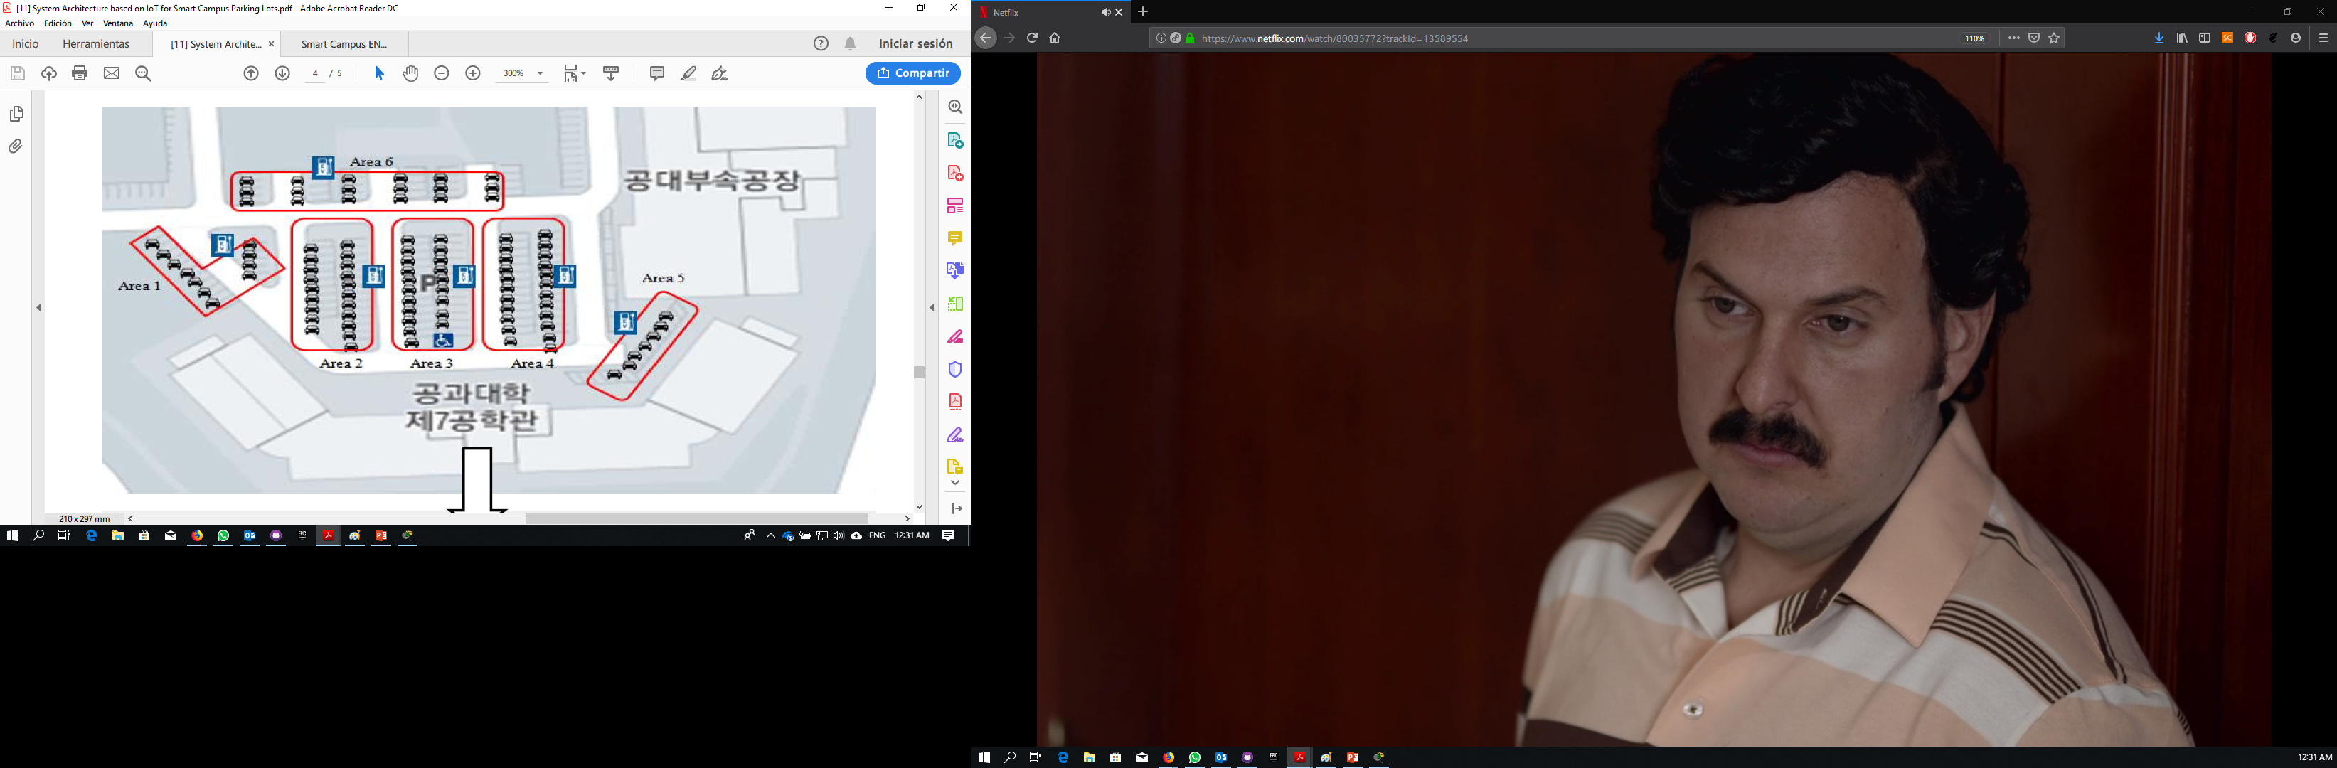

**Figure 5. Diagram University of Korea**

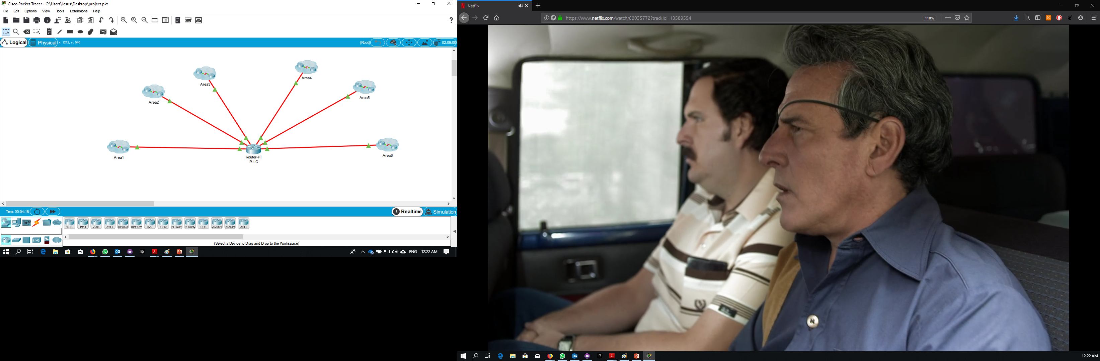In figure 1 we find the distribution of the loading stations that are part of our grid, we have 6 feeders each subdivided in a specific area, in figure 6 we see the distribution made in the CISCO PACKET TRACER software with the real distances and the equipment that we use .

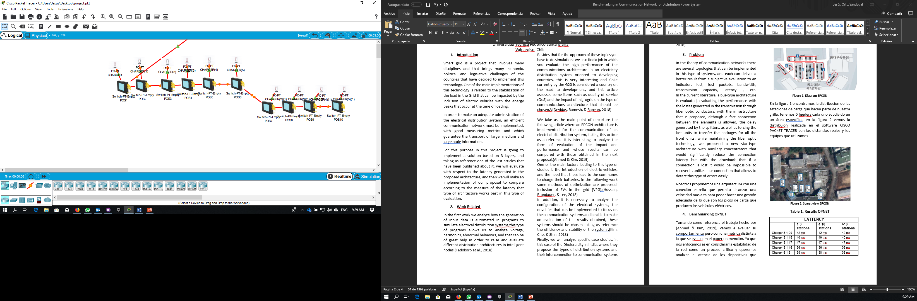

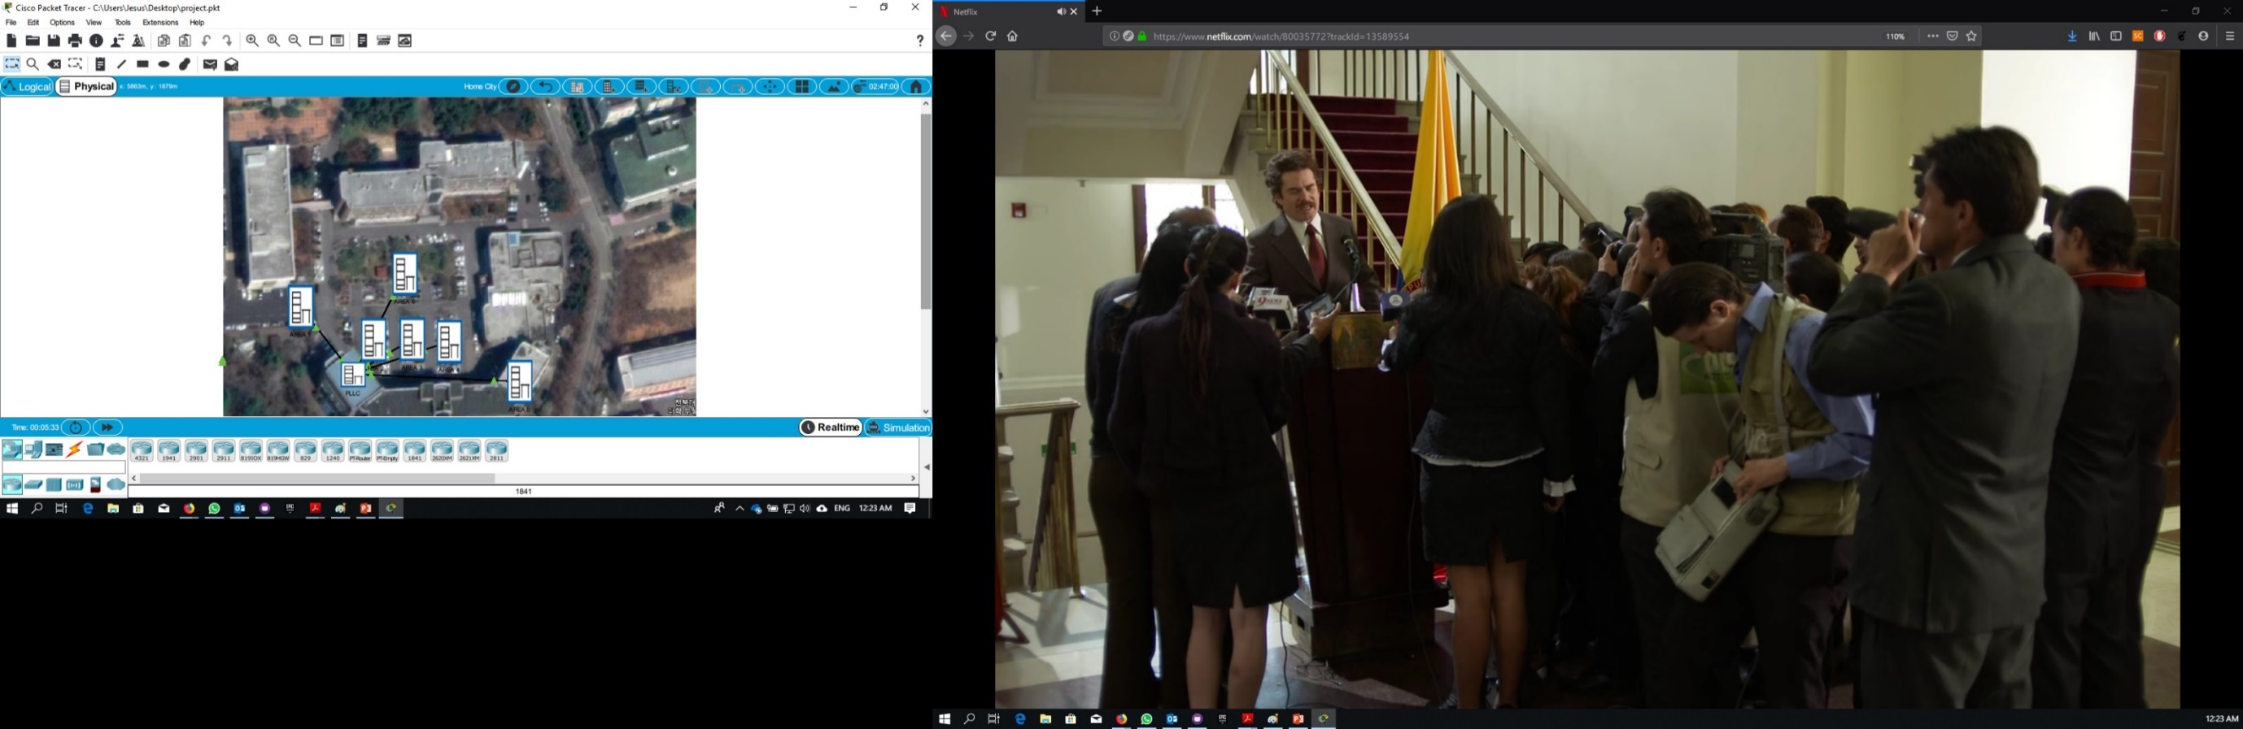**Figure 6a. Logical network**

**Figure 6b. Real view University of Korea**

In Figure 6b we observe the real view of the case study, obtained by Google Street View, this configuration is enabled in the same way by Cisco Packet Tracer. In table 4 we have the results made in load mode transmitting a packet of 32 bits per second sending, status of the charging station, battery condition of the electric vehicle, cost of the transaction, identification of the vehicle that is being loaded. The first design maintains the same topology of the electrical distribution system, analyzing 3 cases, with low, medium and high information traffic.

**Table 4. Results EPON with Fiber**

Thanks to the information obtained in the first presentation, the same type of technology is evaluated but using a star architecture, using wireless transmission, but with the same simulation conditions of the previous case study, the configuration of the equipment is found in the figure 7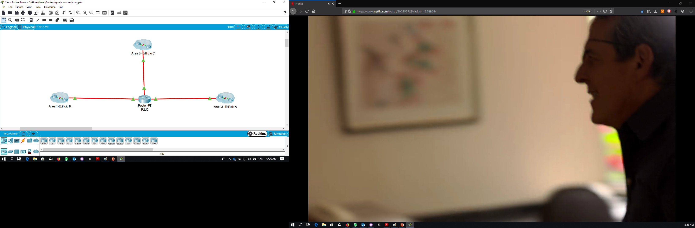 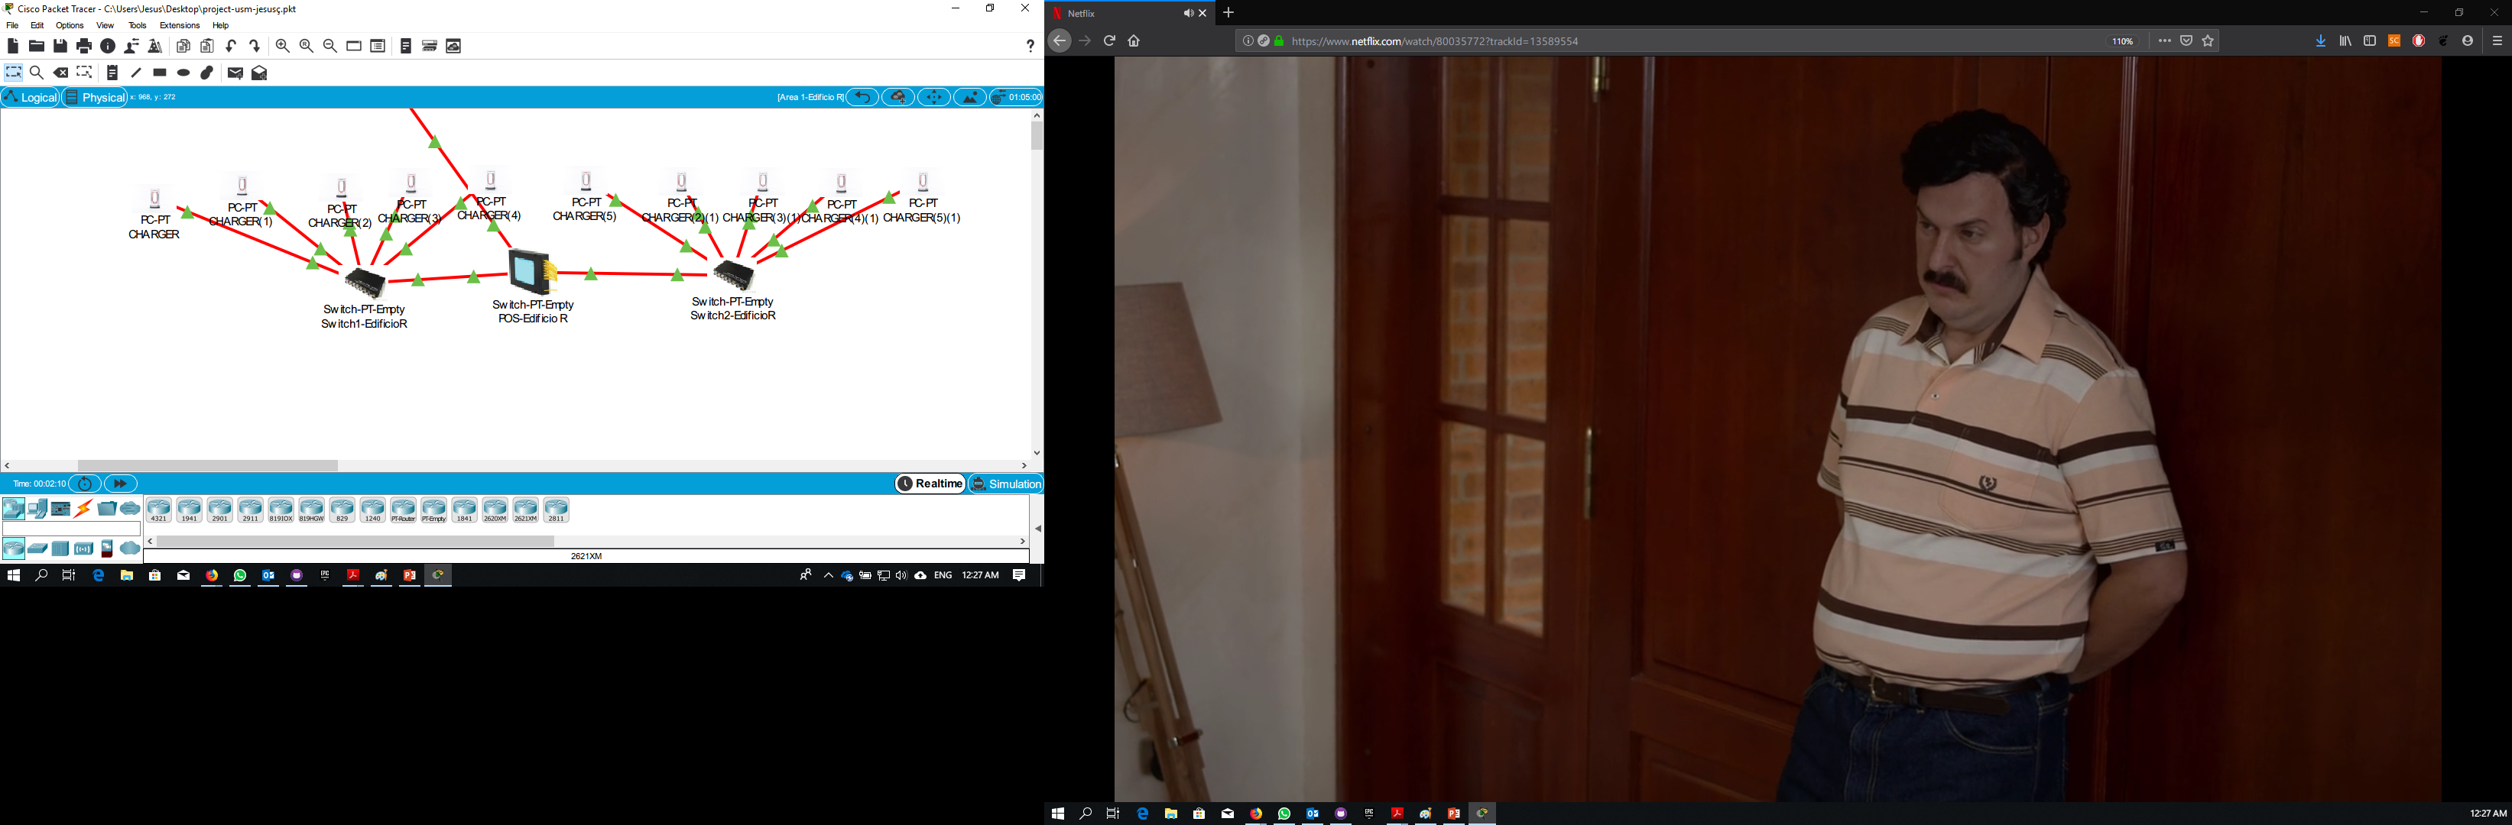

**Figure 7. Star topology with WIFI**

In table 5 we find that although the times increase, it is not an increase that can be considered very harmful for the transmission, this indicates that it is viable for the electrical distribution system to use an EPON network and for the communication layer to work with a Different architecture that allows us to save costs related to infrastructure and excessive cabling.

**Table 5. Results EPON with Wireless**

|  |  |  |  |
| --- | --- | --- | --- |
|  | **1-3 stations** | **4-10 stations** | **>10 stations** |
| Charger 3-1-20 | 102 ms | 102 ms | **102 ms** |
| Charger 3-1-18 | 90 ms | 90 ms | **90 ms** |
| Charger 3-1-17 | 101 ms | 101 ms | **101 ms** |
| Charger 3-1-16 | 95 ms | 95 ms | **95 ms** |
| Charger 6-1-5 | 97 ms | 97 ms | **97 ms** |
| Charger 5-1 | 86 ms | 86 ms | **86 ms** |
| Charger 6-1-15 | 94 ms | 94 ms | **94 ms** |
| Charger 4-1-7 | 89 ms | 89 ms | **89 ms** |

**Conclusions**

We managed to demonstrate with the simulation that the design is correct, we have a margin of error but it is not very big and above all it is reflected in the theoretical part.

Taking as a reference the article of Huang 2017, the standard values of losses for the splitters were taken, (0.4 and 11), but in reality those values are far from the values found in the simulation, this difference is the one that introduces the error in the system

It is very important to implement a power distribution system to have enough tools to do the modeling of the system and its subsequent simulation to evaluate and be taken to an implementation.

A very interesting methodology is developed, approaching two layers of the three possible layers in a communication system of an intelligent grid, this allows us to have practical and theoretical results related to variables such as losses and latency.

**References**

Ahmed, M. A., & Kim, Y. (2019). *System Architecture based on IoT for Smart Campus Parking Lots*. 0–4.

Devidas, A. R., Ramesh, M. V., & Rangan, V. P. (2018). High performance communication architecture for smart distribution power grid in developing nations. *Wireless Networks*, *24*(5), 1621–1638. https://doi.org/10.1007/s11276-016-1400-2

Hussain, M. A., Brandauer, W., & Lee, M. J. (2018). Mobility-Aware Vehicle-to-Grid (V2G) Optimization for Uniform Utilization in Smart Grid Based Power Distribution Network. *Mobile Networks and Applications*. https://doi.org/10.1007/s11036-018-1048-5

Kim, J. C., Cho, S. M., & Shin, H. S. (2013). Advanced power distribution system configuration for smart grid. *IEEE Transactions on Smart Grid*, *4*(1), 353–358. https://doi.org/10.1109/TSG.2012.2233771

Pandya, R., Velani, K., & Karvat, D. (2018). Design of Smart Power Distribution Network for Smart City-Dholera. *Proceedings of the 2018 International Conference on Current Trends towards Converging Technologies, ICCTCT 2018*, (Dmic), 1–5. https://doi.org/10.1109/ICCTCT.2018.8550980

Tadokoro, T., Noda, T., Ishimoto, K., Okada, N., Uemura, S., & Shumuta, Y. (2018). Automatic Generation of Input Data for Distribution System Simulation Programs. *International Conference on Innovative Smart Grid Technologies, ISGT Asia 2018*, 25–29. <https://doi.org/10.1109/ISGT-Asia.2018.8467719>

Guo Jing-tian, Zhai Chun-heng, Liu Xing-hua, Zhu Guo-fang, Hou Mei-yi, Zou Gui-bin, … Zhang Ning. (2014). *Application of IEEE1588 in Time Synchronizing System of Smart Distribution Grid*. 12.65-12.65. https://doi.org/10.1049/cp.2014.0138

Huang, H., & Zhang, H. (2011). Application and Analysis of Long-Distance EPON in Transmission Lines Monitoring System. *Advanced Materials Research*, *317*–*319*, 1583–1589. https://doi.org/10.4028/www.scientific.net/amr.317-319.1583

Sun, Z., Guo, Q., Ma, Y., & Sun, F. (2010). *Communication System for Distribution Automation Using EPON*. 1–4. https://doi.org/10.1109/cise.2009.5363237